

EMC Test Report

Product: | Compact VariTime Sync Generator
Type No: | PT 5201 / LT 428
Standards: | EN 55103-1  EN 55103-2
Report No: | B2002052
Date and Signature: | ____________________________

Test object: Compact VariTime Sync Generator, PT 5201 / LT 428

Manufacturer: DK-AUDIO A/S
Marielundvej 37D
DK-2730 Herlev
Denmark

Test dates: 17 - 24 June 2002

Standards: Emission: Product family standards EN 55103-1/1996
Product family standards EN 61000-3-2/1995 and
EN 61000-3-3/1995

Immunity: Product family standards EN 55103-2/1996

Test engineer: Kim Boll Jensen

Test laboratory: All tests are made in the test laboratories of LK , Industriparken 32, 2750 Ballerup
All tests are made by Kim Boll Jensen, Bolls Rådgivning.

Conclusion: The product has been tested according to the above mentioned standards and has been found to fulfil the requirements.
This gives presumption of compliance for the protection requirements given in article 4 of the EMC directive 89/336/EEC and the unit can be CE-marked according to this directive.

Table of contents

1. Introduction 4
1.1 General 4
1.2 Summery of tests 4
1.3 Test set-up 5
Definition of performance criterions for immunity testing : 6
2. Environments 6
3. Emission test: EN 55022 (and FCC) 7
4. Harmonic Current: EN 61000-3-2 8
5. Voltage fluctuations and flicker: EN 61000-3-3 9
6. ESD-Test: EN 61000-4-2 10
7. EM Field immunity; EN 61000-4-3 12
8. Burst Test: EN 61000-4-4 13
9. Surge: EN 61000-4-5 14
10. RF immunity on cables: EN 61000-4-6 15
11. Power freq. magnetic field: EN 610004-8 16
12. Voltage dips/interruptions and Inrush: EN 61000-4-11 17
13. Attachment 18
List of instruments: 21

Introduction

General

The purpose of this report is to describe the tests that this product has been submitted to. These tests have been performed to verify that EMC requirements for the product are met.

Summery of tests

Phenomenon | Used Basic standard | Test on | Result
Radiated emission | EN 55022/09.98  CISPR 22/11.97 | Enclosure port | requirements fulfilled
Conducted emission | EN 55022/09.98  CISPR 22/11.97 | Input AC power port | requirements fulfilled
Harmonic current emission | EN 61000-3-2/04.95 with Amd.1/04.98 and Amd. 2/04.98 | Input AC power port | requirements fulfilled
Inrush | EN61000-4-11 | Input AC power port | requirements fulfilled
Voltage fluctuation and flicker emission | EN 61000-3-3/ 01.95 | Input AC power port | requirements fulfilled
Radiated RF immunity  80-1000 MHz, 80 %  1 kHz AM modulated | IEC 61000-4-3 | Enclosure port | requirements fulfilled
Conducted RF immunity | IEC 61000-4-6 | Input AC power port  Signal ports | requirements fulfilled
Conducted fast transient immunity | IEC 61000-4-4 | Input AC power port  Signal ports | requirements fulfilled
Conducted surge transient immunity | IEC 61000-4-5 | Input AC power port | requirements fulfilled
ESD immunity | IEC 61000-4-2 | Enclosure port | requirements fulfilled
Voltage dips and interruptions immunity | IEC 61000-4-11 | Input AC power port | requirements fulfilled

Test set-up
Monitor:
Barco, CVM 22A
or
Philips, PM 5625
Digital Audio monitor;
Tektronix, 764

Digital video component analyzer;
R&S, VCA
Waveform Monitor;
PorTeleVision, PM5661

Varitime digital sync generator;
Plilips PT5210

4 m unshielded cable
All 5m long 75 ohm coax cables

DK-AUDIO;
PT5201 / LT 428
EUT

Definition of performance criterions for immunity testing :

Performance criterion A :

The apparatus shall continue to operate as intended. No degradation of performance or loss of functions is allowed below a performance level specified by the manufacturer.

Performance criterion B:

The apparatus shall continue to operate as intended after the test. No degradation of performance or loss of functions is allowed below a performance level specified by the manufacturer.

Performance criterion C :
Temporary loss of functions is allowed provided the function is automatically restored when the stimulus is removed, or can be restored by operation of the controls.

Please refer to EN 55103-2 for full details of the performance criterion.

Environments
Electromagnetic environment E2 is chosen for this equipment. This covers Commercial and light industrial (including, for example, theatres).

Emission test: EN 55022 (and FCC)
Test applicable [ ] Not applicable [ X ]. Comment:
Deviations in test setup:

Measurements (shortform) :
Test setup shall be normal use with max. load according to standards.
In the TEM-cell, the product shall be measured from three different sides and each measurement is indicated on the test sheets. The corrected limits shall be indicated on the sheets.

Conducted emission can be measured in a shielded room or outside, just remember to use a HF-ground plane according to the standard.
Test sheets shall always be attached to this test.

Test : | OK / not OK | Comments :
TEM Cell :
Open test site :
Conducted mains:
Conducted tele port
FCC part 15, B

Comments

Emission is not included in this report

Tested by :
Date :

Harmonic Current: EN 61000-3-2
Test applicable [ ] Not applicable [ X ]. Comment:
Deviations in test setup:
Number of test sheets: in Attachment No.:

Scope
Applicable to mains operated equipment (>= 220Vac) with input current <= 16A per phase.
Not applicable if max. power < 75W

Measurements (shortform) :
Test setup shall be normal use with max. load according to standards.
Input Voltage shall a sin. Voltage with minimum distortion.

Class: | A | B | C | D
Equipment Class:
Pass Class:

Test results shall be attached for this test.

Comments

Mains input power = max 27W

Since mains input power < 75 W this standard is not applicable. (See clause 7 of EN 61000-3-2:1995 + A14:2000)

Tested by :
Date :

Voltage fluctuations and flicker: EN 61000-3-3
Test applicable [ X ] Not applicable [ ]. Comment:
Deviations in test setup:

Scope
Applicable to mains operated equipment (>= 220Vac) with input current <= 16A per phase.

According to § 6.1 of this standard, test shall not be made on equipment which is unlikely to produce significant voltage fluctuations or flicker.

Based on statement from DELTA accredited testhouse, small E-type transformer (wall plug) complies without test.

Measurements (shortform) :
Test setup shall be normal use with max. load according to standards.

Value | Limit | Measured value
*Pst | 1.0
*Pit | 0.65
d_{c} steady-state | ≤ 3%
d_{max} | ≤ 4%
d_{(t)} during voltage change | > 3% in less than 200 ms
*If voltage changes are caused by manual switching or occures less than once per hour this requirements do not apply

Comments

According to EN 61000-3-3 Clause 6.1 no test is needed if: Inrush <= 20A and after inrush the variation is within 1.5A.

Inrush = 7.4 A

Steady current 0.11 (max. variation 0.05A)

Tested by : Kim Boll Jensen
Date : 2002-06-17

ESD-Test: EN 61000-4-2
Test applicable [ X ] Not applicable [ ]. Comment:
Deviations in test setup:

Test 1 (shortform) :
Discharge on product on typical operator accessible points.

Contact: 10 discharges pr. points, min. 1 sec. interval (per polarity) min. different 4 points.

Air dischagres: at slots, apertures and insulating surfaces. 10 dischagres pr. Points

No discharge to open connectors.

EN 61000-4-2 level : 3 for air discharge ( 8 kV) and level 2 for contact discharge (4 kV).
Test is performed with increasing voltages 2, 4, 8 kV

Performance criterion B

No | Discharge point | Number of discharges | Voltage  Polarity | Air  OK | Contact OK
1 | Font RS 232 | 10 | ± | OK | OK
2 | Front LED | 10 | ± | OK | OK
3 | Top front at screw | 10 | ± | OK | OK
4 | Back connector; Audio L | 10 | ± | OK | *OK
5 | Back connector; SDI | 10 | ± | OK | *OK
6 | Back connector; Video | 10 | ± | OK | OK
7 | Back connector; BB1 | 10 | ± | OK | OK
8 | Back connector; GENLOCK | 10 | ± | OK | OK
9 | Back connector; LOOP | 10 | ± | OK | OK
10
11
12

Comments :

At 4Kv the R&S analyzer detects an error, but all test equipments and PT 5201 continues in normal operation. The PT 5201 pass the performance criterion B

Test 2 (shortform) :
Discharges on the horizontal coupling plane (HPC) (ground plane) and vertical coupling plane (VPC) according to standard.
10 discharges on each position min. 1 sec. interval applied to the edge of the plans in center of the equipment.

EN 61000-4-2, level 2 for contact discharge (4 kV).

Performance criterion B

No | Positions | Number of discharges | Voltage  Polarity | Contact OK
1 | In front of product at HPC | 10 | + | OK
2 | In front of product at HPC | 10 | - | OK
3 | In front of product at VPC | 10 | + | OK
4 | In front of product at VPC | 10 | - | OK
5 | Behind product at VPC | 10 | + | OK
6 | Behind product at VPC | 10 | - | OK
7 | Left side of product at VPC | 10 | + | OK
8 | Left side of product at VPC | 10 | - | OK
9 | Right side of product at VPC | 10 | + | OK
10 | Right side of product at VPC | 10 | - | OK

Comments:

Tested by : Kim Boll Jensen
Date : 2002-06-17

EM Field immunity; EN 61000-4-3
Test applicable [ X ] Not applicable [ ]. Comment:
Deviations in test setup:

Measurements (shortform) :
Test setup shall be normal use with max. load according to standards.
80 to 1000 MHz 80% AM (1kHz), at minimum 3 Volt/meter.
The product shall be observed during the test and be operating. After test, the product should be tested to be sure that no errors or changes in mode have occurred.

Performance criterion A.

Antenna &  product position : | 80M–1GHz  OK/not OK |  | Comments:
Vertical & front : | OK
Vertical & left side : | OK
Horizontal & front : | OK
Horizontal & left side : | OK

Comments

Tested by : Kim Boll Jensen
Date : 2002-06-17

Burst Test: EN 61000-4-4
Test applicable [ X ] Not applicable [ ]. Comment:
Deviations in test setup:

Test 1 - immunities on powerport :

Product is in normal operating mode.
1 KVolt on AC and 0.5 KVolt on DC. Both on AC- and DC- port the coupling network shall be used.
Test is performed as 1 min. positive and 1 min. negative pulses.
If product have power outputs AC or DC, they shall also be tested with same procedure.

Performance criterion B
Test applicable [ X ] Not applicable [ ]. Comment:
Port : | 0,5 K Volt  + - |  | 1 K Volt  + - |  | Comments:
AC-port : CM | OK | OK | OK | OK
Earth port | OK | OK | OK | OK

Test 2 - immunities on signal- and controlport :
(Test is only performed if connection cable is over 3 meter.)
Product is in normal operating mode. Test set-up according to IEC 61000-4-4. Signal or control cables shall be placed in the capacitive coupling clamp.
Test is performed as 1 min. positive and 1 min. negative pulses.

Performance criterion B
Test applicable [ X ] Not applicable [ ]. Comment:
Signal : Control cable : | 0.5 k Volt  + - |  | Comments
Audio L | OK | OK
SDI | OK | OK | *TRS errors detected by R&S analyzer, nothing else affected, continues after burst test
Video | OK | OK
BB1 | OK | OK
GENLOCK | OK | OK

Comments

* With a reduction of the test level to less than 400V the equipment did still fail. But complies with performance criterion

Tested by : Kim Boll Jensen
Date : 2002-06-17

Surge: EN 61000-4-5
Test applicable [ X ] Not applicable [ ]. Comment:
Deviations in test setup:

Test 1 - immunities on AC/(DC) powerport :
AC:CM1 KVolt.
AC:DM 0.5 KVolt

DC: 0.5 KVolt Line to ground only if DC port can connect directly to outdoor cables.
Couplings network is used, and both positive and negative pulses are used, minimum 1 minute between pulses and at least 5 pulses of each.

Performance criterion B
Test applicable [ X ] Not applicable [ ]. Comment:
Port : | 0,5 K Volt  + - |  | 1 K Volt  + - |  | 2 K Volt  + - |  | Comments
CM; L – PE |  |  | OK | OK
CM; N – PE |  |  | OK | OK
DM; L - N | OK | OK

Comments

Tested by : Kim Boll Jensen
Date : 2002-06-24

RF immunity on cables: EN 61000-4-6
Test applicable [ X ] Not applicable [ ]. Comment:
Deviations in test setup:

Scope
Test applies to AC/DC power ports and signal ports if cable is or can be longer than 3 m.

Test
0,15 – 80MHz minimum 3V/m 80% AM.
Test setup as pr. standard. Product in normal operating mode.

Performance criterion A
Cable: | 0,15 – 80MHz  OK/not OK | Comments:
Mains | OK | 1) See below
SDI | OK | 2)
VIDEO | OK | 3)
BB1 | OK | 4)
GENLOCK | OK | 5)
AES | OK | 6)

Comments
1) The picture got some dark stripes from 2MHz to 4.5MHz
At 3.5MHz to 5MHz it got noise all over the picture. Both problems could be solved by connecting the functional earth to the groundplane.
At 20 MHz to 27MHz the dark stripes came back, this time only a ferrite on the mains cord could stop it.
By using the Philips monitor the problems disappeared.

2) 2.5 to 5MHz the picture got some dark strips, but this time it was the BARCO display unit which was sensible. A better earth connection at the BARCO unit solved the problem.
At 11, 13 and 45MHz the problems came again, it was reduced by better earth connection between all monitoring equipments.
By using the Philips monitor the problems disappeared.

3) At 6 – 6.8MHz the signal was total mess, by earth connection of the video cable between BARCO monitor and DFT the signal was OK.
Some strips at 20-25 and 32-37MHz
By using the Philips monitor the problems disappeared.

4) At 3.8 – 8MHz strips in picture, at 6.6MHz the picture was total mess, all problems solved by earthing as in 3)
Strips at 45-50MHz couldn’t be solved.
By using a new monitor the problems disappeared.

5) Very small strips at 6.6MHz and again from 20-28MHz
By using the Philips monitor the problems disappeared.

6)At 6-7MHz small noise strips in picture and again at 22- 28 MHz
By using the Philips monitor the problems disappeared.

All problems was related to the Barco monitor. By measuring the noise signals in worst case it wasn’t over rating of the product. Therefore the problem have nothing to do with the EUT.

Tested by : Kim Boll Jensen
Date : 2002-17-06 and 2002-06-24

Power freq. magnetic field: EN 610004-8
(This test is only applicable to equipment containing devices susceptible to magnetic fields, such as CRT monitors, Hall elements, electrodynamics microphones, magnetic field sensors, etc.)

Test applicable [ ] Not applicable [ X ]. Comment:
Deviations in test setup:

Scope
Test applies to enclosure (including cables)

Test
50Hz 1 A/m (r.m.s.)
Test setup as pr. standard. Product in normal operating mode.
Test is performed in three directions.

Performance criterion A

H-field direction | OK / Not OK | Comments:
Vertical 1
Vertical 2
Horizontal

Comments

Tested by :
Date :

Voltage dips/interruptions and Inrush: EN 61000-4-11
Test applicable [ X ] Not applicable [ ]. Comment:
Deviations in test setup:

The voltage is adjusted to 230 Vac and the following dips/interruptions are introduced:

Reduction in % | Voltage | Time | OK / not OK | Performance criteria | Comment
>95% | >11.5 Vac | 5 sec. | OK | C
60% | 92 Vac | 100 ms | *OK | C
100% | 0 Vac | 20 ms | OK | B

Max. Inrush current measured at >95%@ 5 sec at 0 crossing = 7.4 A (average inrush = 5.05A)

Comments

* It did pass more than 200ms.

Tested by : Kim Boll Jensen
Date : 2002-06-17

Attachment

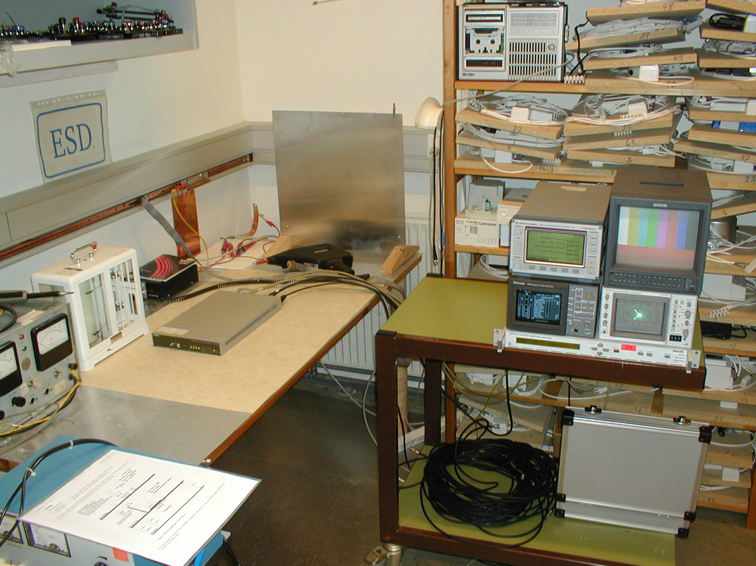

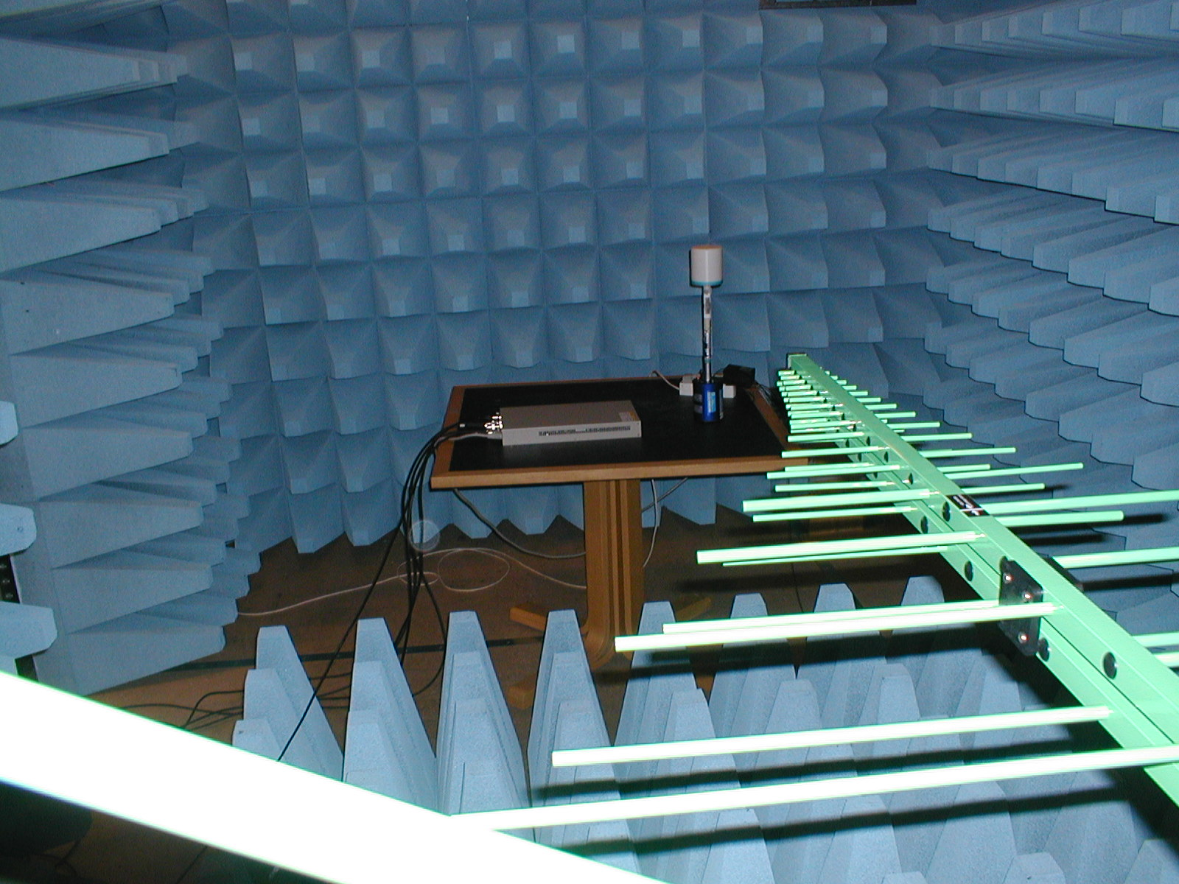
ESD test
HF immunity test
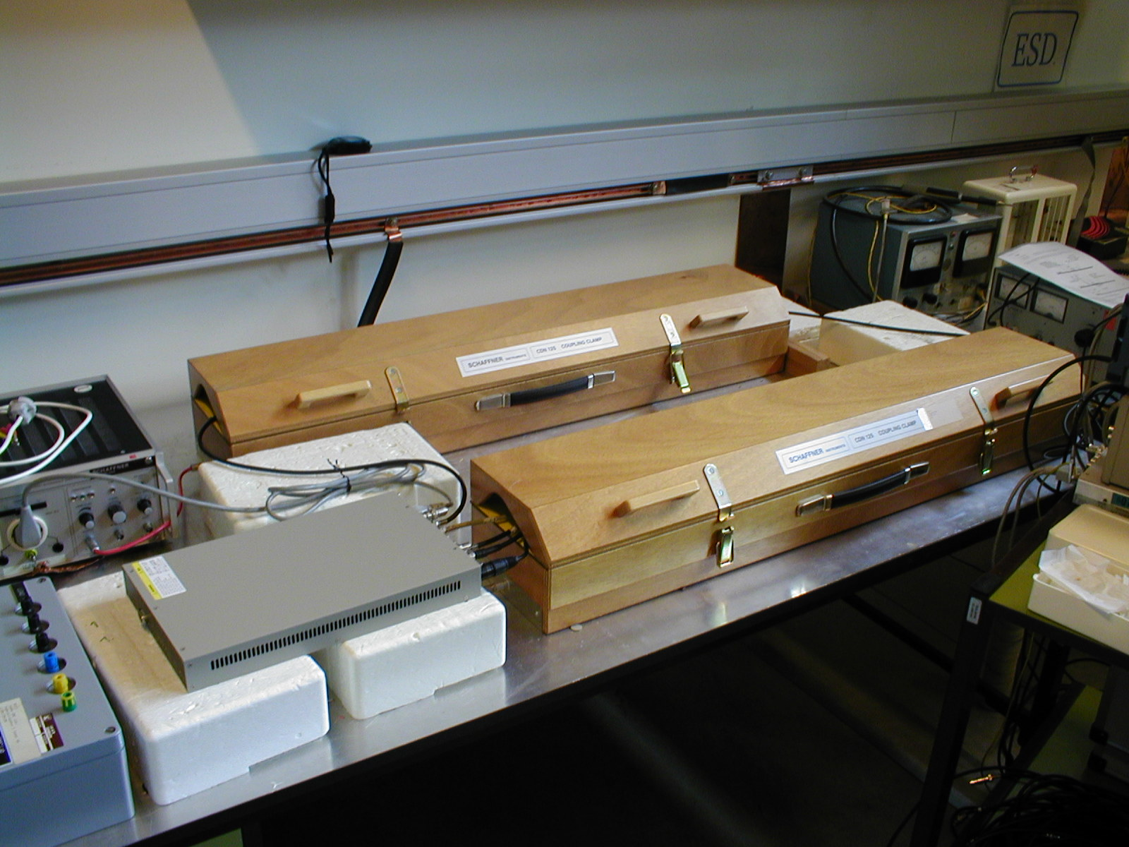
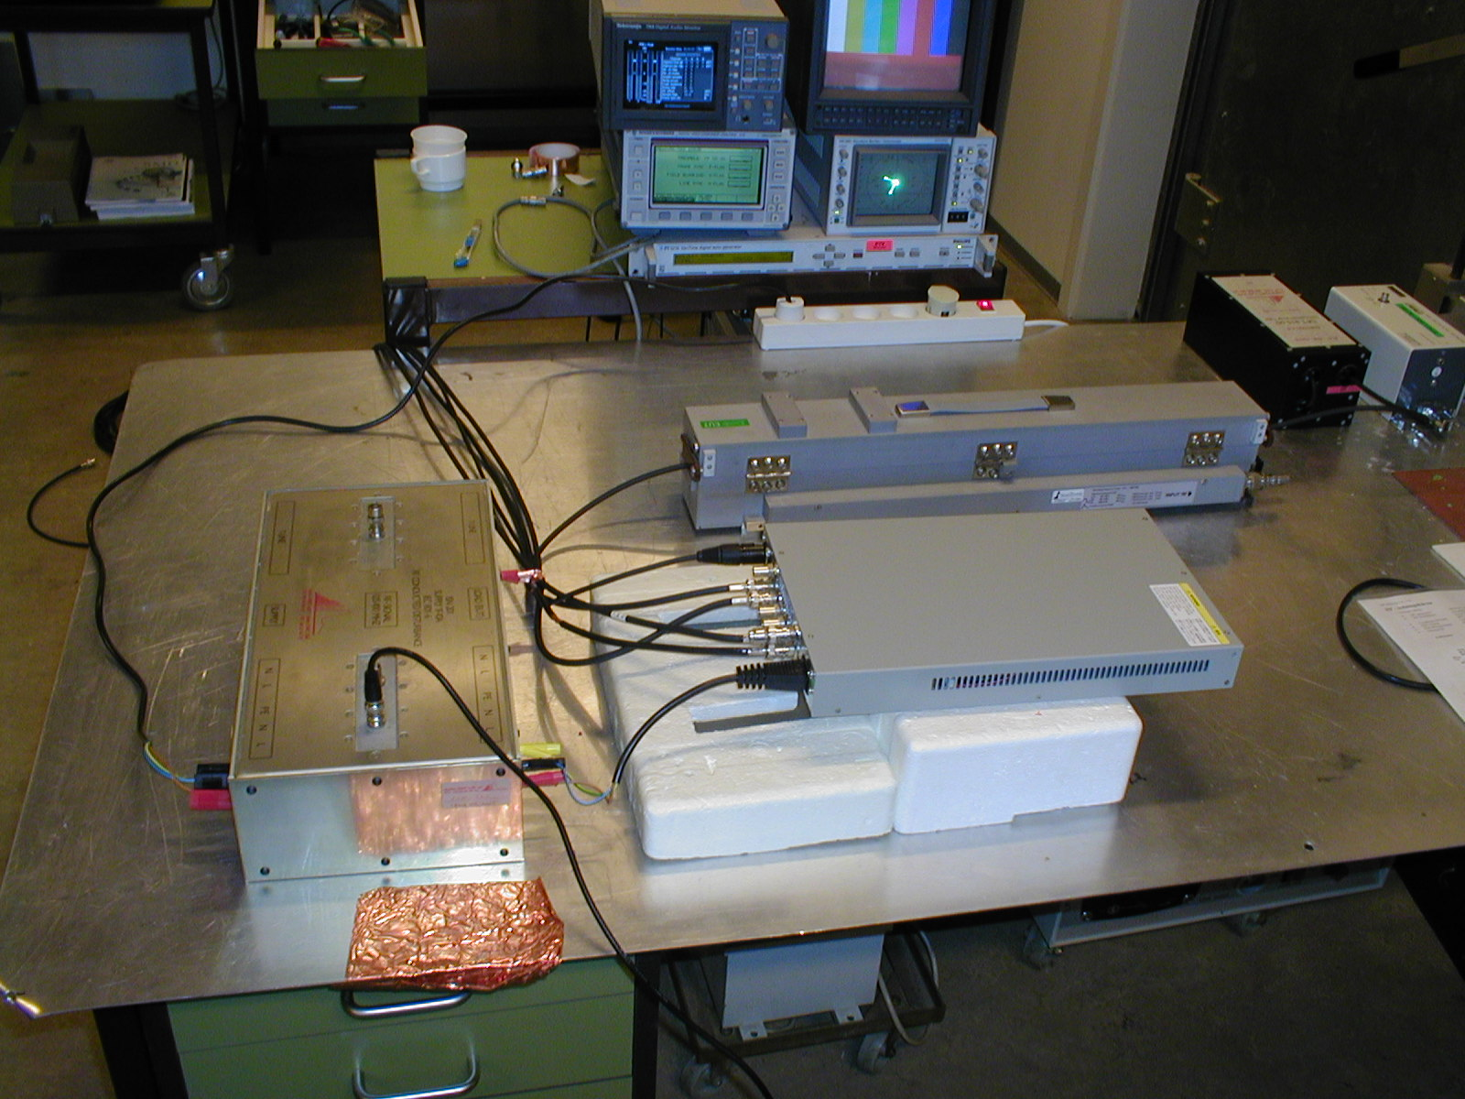
HF conducted immunity test
Burst test
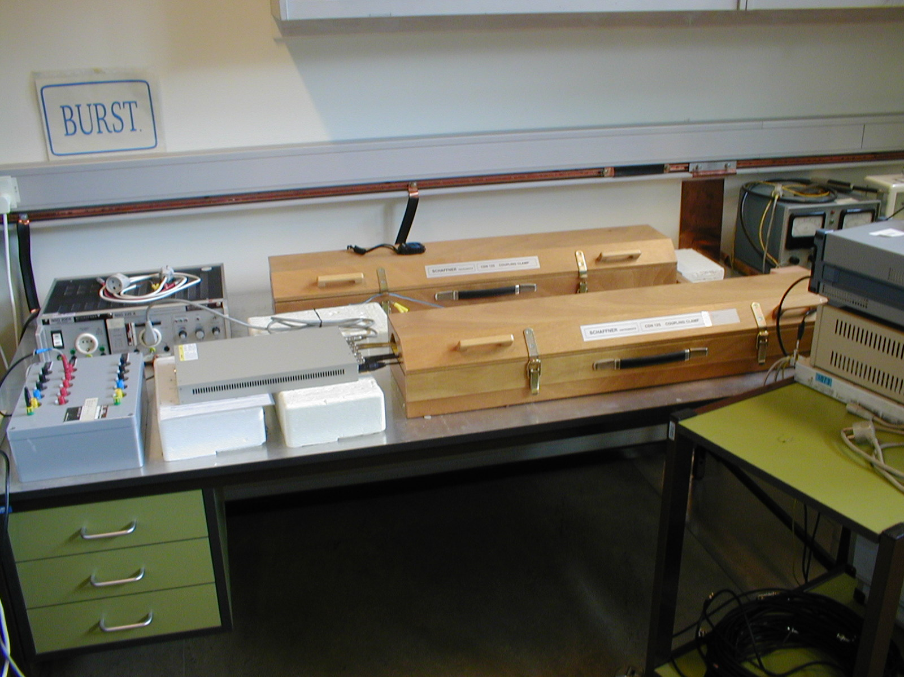
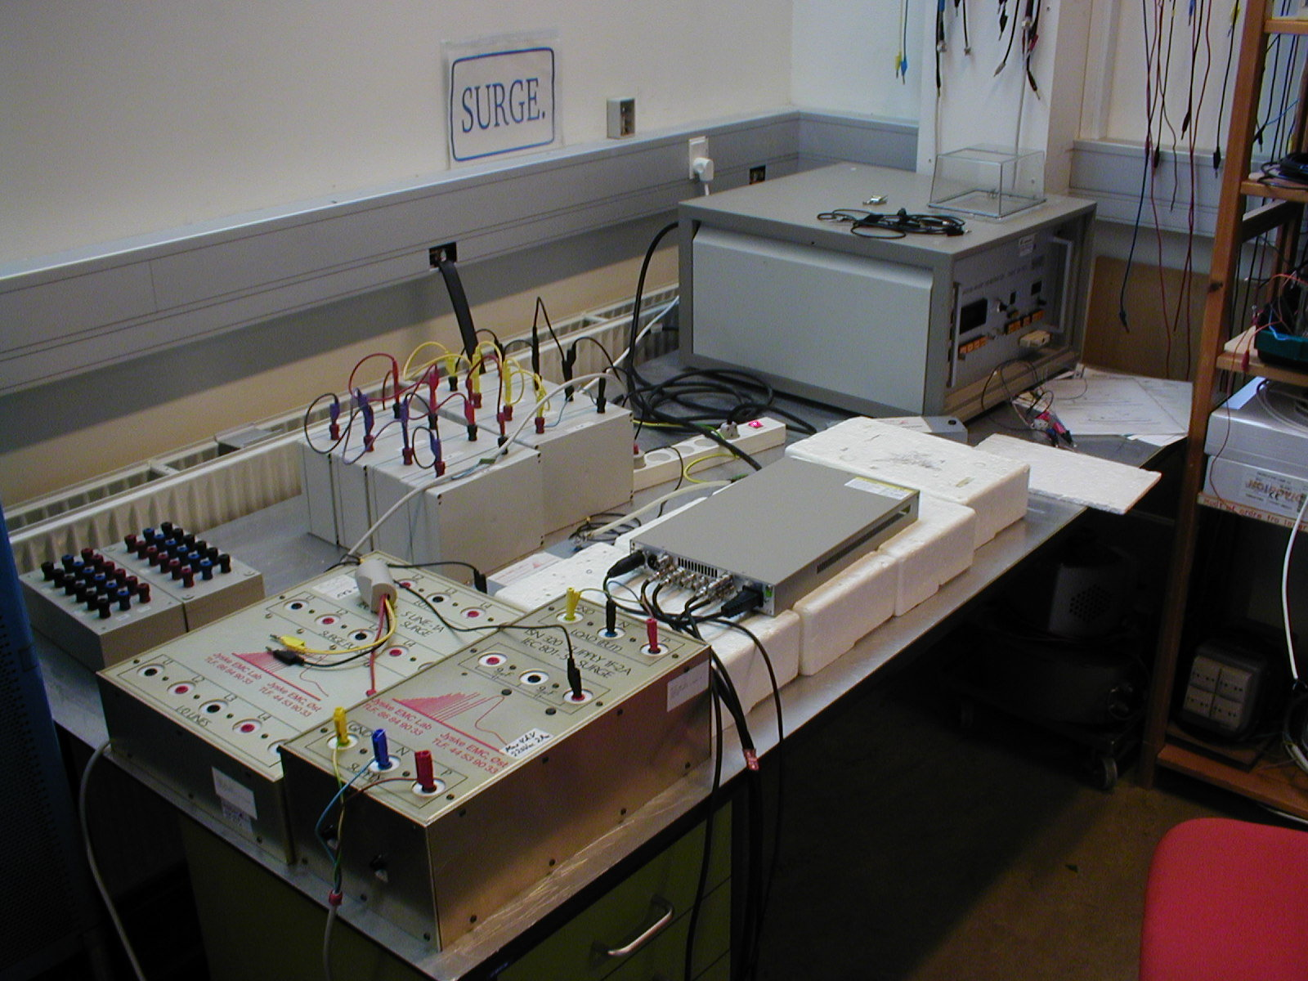
Burst test
Surge test

List of instruments:

Radiated emission:

Instrument | Manu-facturer | Type | Instrument number | Calibrated  at | Last calibration | Next calibration
Test receiver | Advantest | 3361A |  | Arepa | 12.06.2002
Antenna | Schaffner | Bi-Log CBL6112B
Amplifier | HP | 8447D | P 62094
Software | Schaffner-Chase | EMC EMI PAK EPS9980-1.31
Shielded room | Lindgren-Rayproof | S81

Conducted emission:

Instrument | Manu-facturer | Type | Instrument number | Calibrated  at | Last calibration | Next calibration
Test receiver | Advantest | 3361A |  | Arepa | 12.06.2002
Software | Schaffner-Chase | EMC EMI PAK EPS9980-1.31
LISN | Farnell | LSN 30 | AN-6

Radiated RF immunity:

Instrument | Manu-facturer | Type | Instrument number | Calibrated  at | Last calibration | Next calibration
Generator | Marconi | 2023 |  | Arepa | 11.06.02
Amplifier | Amplifier Research | 30W1000M7 | AP-3  AFD.117
Antenna | Schaffner | Bi-Log CBL6112B
Field meter | PMM | 8051 |  | NPL | 27.02.02
Shielded room | Lindgren-Rayproof | S81

Conducted RF immunity:

Instrument | Manu-facturer | Type | Instrument number | Calibrated  at | Last calibration | Next calibration
Generator | Marconi | 2023 |  | Arepa | 11.06.02
Amplifier | Amplifier Research | 75A250 | AP-4
Decoupling ferrite tube | Jyske EMC | DFT 810
Coupling/De-coupl. network | Jyske EMC | ISN 201
EM-clamp | Lüthi | EM101 | EG-14
50 Ω load | HP | 11593A  50 Ω
50 Ω load | Lüthi | 50 Ω

Conducted fast transient immunity:

Instrument | Manu-facturer | Type | Instrument number | Calibratedat | Last calibration | Next calibration
Generator | Schaffner | Nsg 200E + NSG 225A | EG-5 | Arepa | 10.06.02
Capacitive coupling clamp | Schaffner | CDN 125
Capacitive coupling clamp | Schaffner | CDN 125 | EG-8

Conducted surge transient immunity:

Instrument | Manu-facturer | Type | Instrument number | Calibrated  at | Last calibration | Next calibration
Generator | HILO/TEST | CWG 10/503 |  | Arepa | 12.06.02
Coupling/De-coupl. network | Jyske EMC | ISN 320 | EG-15

Electrostatic Discharge immunity:

Instrument | Manu-facturer | Type | Instrument number | Calibrated  at | Last calibration | Next calibration
Generator | Schaffner | NSG 432 +adapter for contact | EG-18 | Arepa | 09.10.01

Voltage dips and interruptions immunity:

Instrument | Manu-facturer | Type | Instrument number | Calibrated  at | Last calibration | Next calibration
Generator | Schaffner | NSG 200C + 203A | EG-3
Voltmeter | Fluke | 8010A | UV-15 | LK | 03.2002
Osc. Scope | Tektronix | TDS220
Current meter | Voltech | PM1200 | W-14 | LK | 02.2002

